Project Documentation

Part 0: About this project
Let us consider our college computer network(computer network is just a collection of different machines on internet communicating with each other). Let us consider just 2 computers, computer A and Computer B as of now.
Computer A wants to send some data or communicate with Computer B to request data. This will generate network traffic. Millions of such traffic flows are generated when many computers on the internet communicate with each other.
Sometimes, during this flow of traffic, someone may try to steal the data, scan the traffic or attack in some ways such that this causes harm to the parties involved in the communication. To solve such problems, we need some way to classify the traffic as harmless or harmful by looking at the characteristics of the traffic.
This project uses machine learning model to detect such traffic and display the information showing whether the traffic is normal or suspicious and if suspicious, what kind of attack is being carried out.
Traditional methods involve just learning patterns of attacks and then monitoring the traffic but if the attacker tweaks a bit in that attack, then these methods cannot efficiently detect the attacks.

Part 1: Understanding the basic terms
COMPUTER NETWORKS:
Network : Collection of devices communicating with each other.
IP address: It is the unique address which helps to identify a computer on the network
Source IP: The address of the computer which is sending out some information
Destination IP: IP address of the computer which is receiving the information
NOTE:
In our code, we are removing Source IP, destination IP, Timestamp, Flow ID. Because these identifiers can allow the model to memorise the dataset rather than learning attack patterns.
Hence, we remove these columns from the dataset while preprocessing the dataset.
Port: IP address tells us about “which machine” and port tells us about “which service/application in that machine”.
Packet: when we have to send a large file on a network, we won’t send it as one large data file, we will first break it down to few pieces and then send them across the network. These pieces are called as packets.
Network flow: it is the communication between 2 computers/endpoints during a period of time. TO describe this network flow, we won’t store data packets, rather we use some terms which helps us to know about the information about that particular flow.
These terms are:
Duration (for how much time the 2 computers were communicating)
Total packets(how many packets were sent during the given duration)
Total bytes(total bytes sent across the network from one computer to another during a given time(duration).
Packets/sec(how many packets were sent for a second)
Bytes/sec(how many bytes were sent in a second)
And so on..
This is the flow-level representation.

CYBERSECURITY:
It is field which deals with protecting devices, computers and servers on the internet from attacks.
An attack is an activity which intends to steal data, gain unauthorised access, disrupt a system, abuse a service.
There are many attacks to list, but here we talk about the attacks which are given in the dataset.
Denial of Service (DoS/DDoS)
The goal is to make a server or service unavailable to legitimate users.
- DoS Hulk: Floods a web server with a huge volume of unique, randomized HTTP requests. Because each request looks different, caches can't absorb them and the server gets overwhelmed.
- DDoS: Same idea, but the flood comes from many machines at once (often a botnet), so it's harder to block by simply banning one IP.
- DoS GoldenEye: An HTTP flood tool that keeps connections alive and sends requests in ways that exhaust server resources (connection slots, memory).
- DoS slowloris: A "low and slow" attack. It opens many connections and sends partial HTTP headers very slowly, never finishing. The server keeps waiting on each one until it runs out of connection capacity.
- DoS Slowhttptest: A tool that performs slow-style attacks, such as slow headers (like Slowloris) and slow request bodies (like R-U-Dead-Yet), to tie up server connections with minimal bandwidth.
Reconnaissance
- PortScan: The attacker probes a target's ports to find which are open and what services are running. It's usually a first step before a real attack, so it isn't damaging by itself.
Brute-force credential attacks
- FTP-Patator: Uses the Patator tool to guess usernames and passwords against an FTP server.
- SSH-Patator: The same approach against SSH, guessing login credentials to gain remote shell access.
Malware and persistence
- Bot: Traffic from machines infected with botnet malware (in this dataset, the Ares botnet). Infected hosts talk to a command-and-control server and can be told to steal data, take screenshots, or join attacks.
- Infiltration: An attacker gets inside the network, often through a malicious file or exploit on a victim's machine, then uses that foothold to scan and attack other internal systems. It's rare but serious.
Web application attacks
- Web Attack: Brute Force: Repeatedly guessing passwords on a web login page (for example, an admin panel).
- Web Attack: XSS (Cross-Site Scripting): Injecting malicious JavaScript into a web page so it runs in other users' browsers, which can steal cookies, sessions, or data.
- Web Attack: SQL Injection: Inserting malicious SQL into input fields or URLs so the database runs attacker-controlled commands, potentially exposing or altering data.
Vulnerability exploit
- Heartbleed: Exploits a bug in older OpenSSL versions. The attacker sends a malformed "heartbeat" request and the server returns chunks of its memory, which can leak private keys, passwords, and session data.

IDS:
Traditional IDS systems use some predefines rules like:
If X happens, then generate alert
Our project mainly tries to train the ML models such that even if an attacker tweaks a little and tries to send harmful flow, it will be detected.
DATASET:
We are mainly using CICIDS2017 dataset to train the models.
Our main target is the label, benign or malicious.
We are first doing binary classification before going to multiclassification.
Binary classification:
We are taking benign as 0 and malicious as 1 and in binary classification, we are going to classify whether the traffic is benign or malicious(just 2 labels)
After binary classification, we are moving onto multiclassification.
Multiclassification:
Here we are further dividing the malicious as DOS, PortScan and other attacks.
So, here we will find whether the flow is benign or DOS, PortScan etc.,

Part 1: Cleaning the data
Raw data is messy, like a kitchen before cooking. You wash and chop first.
- Load and combine. The data arrives as several CSV files (spreadsheets). They're stacked into one giant table: 2,830,743 rows × 79 columns.
- Tidy column names. Removes invisible extra spaces, which otherwise cause confusing errors.
- Look at the labels. Counting them shows the data is very lopsided: about 2.27 million normal flows, but only 11 Heartbleed flows. This lopsidedness (class imbalance) matters later.
- Remove duplicates. 308,381 rows were exact copies. This is important: if the same row landed in both the "learning" and "testing" piles, the robot would be tested on something it had already memorized, which is like giving students the exam answers in advance.
- Remove broken values. Some cells held "infinity" or were empty (from dividing by zero, for example). Those 1,564 rows were dropped.
- Drop ID-like columns (IP addresses, timestamps, flow ID). These identify who and when, not behavior. If the robot learned "attacks came from this particular computer," it would be cheating and would fail in the real world.
- Drop useless columns where every row has the same value (8 columns). They carry no information.
- Create two kinds of labels:
  - Binary_Label: 0 = normal, 1 = attack (a simple yes/no).
  - Attack_Category: the specific attack name.
- Split into train and test (80/20). The robot studies from the 80% ("train") and is graded on the hidden 20% ("test"). The stratify setting keeps the same normal-to-attack ratio in both piles, so the exam is fair.
- Scale the numbers. One column might be in the millions (duration) and another in single digits (packets). The scaler squashes every column onto a similar range (average 0, typical spread 1), because many models get confused when numbers are wildly different in size. The scaler learns its settings only from the training pile and is then applied to the test pile, so no information from the exam leaks into studying.
- Save as train.csv and test.csv (about 2.0M and 0.5M rows).
Part 2: Exploring the data
Before building anything, you look at the data, like a detective studying evidence.
- Class distribution: about 83% normal, 17% attack. It's imbalanced, but not terribly so.
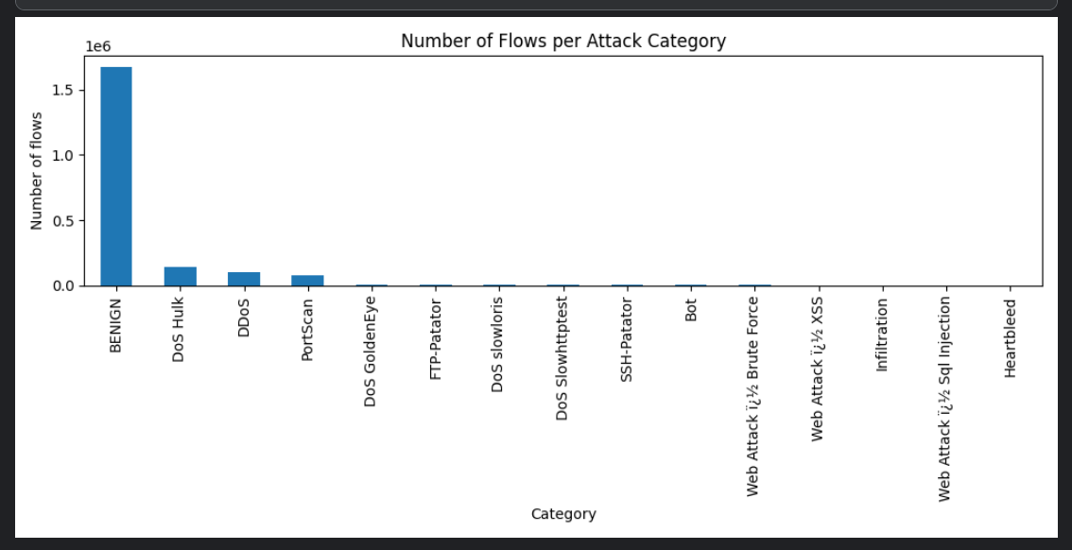
- Comparing normal vs attack on things like flow duration, using averages and boxplots (charts showing the typical range of values). Attack flows tended to last longer than normal ones.
- 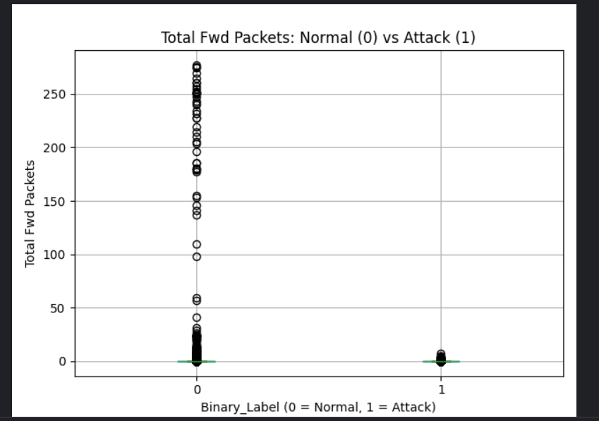
The above plot shows that:
Circles represents the outliers. So the normal category has many outliers. Here attack flows send very few packets while normal traffic sometimes has heavy burst. May attack here use short, tiny flows(portscan, dos).
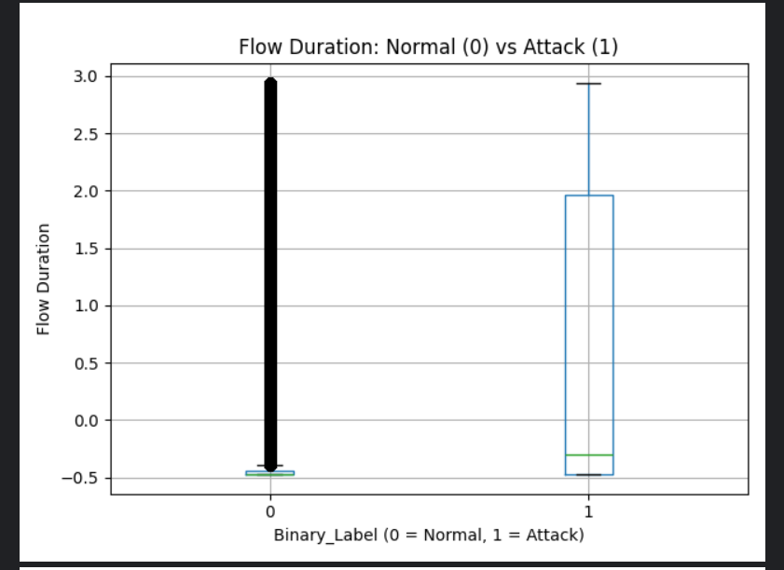
Normal:
The thick back line is nothing but outliers. There are so many outliers such that the line look solid.
Attack:
The median is around -0.3 upto 2.0. so the attacks are more spread out and generally longer.
Slow attacks like slowloris and slowhttptest likely contributed here
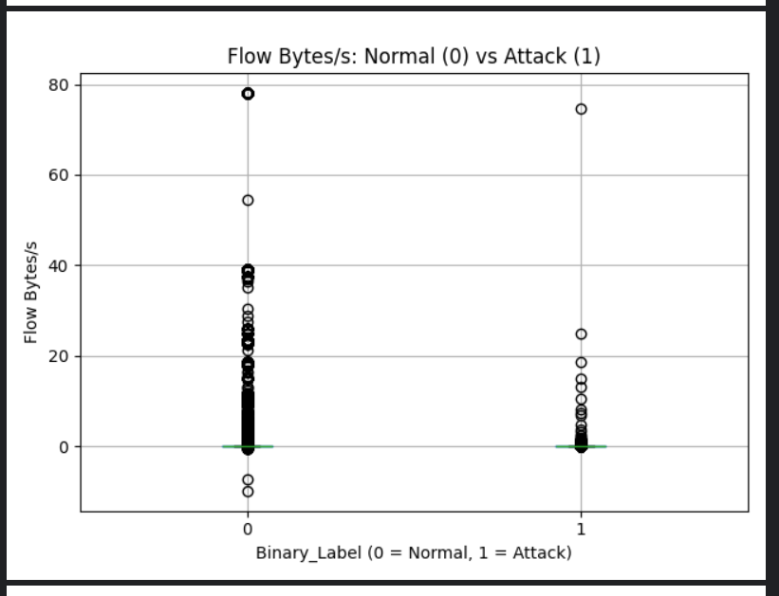
As you can see almost both of them are squeezed to 0 but the outliers are stretched up to 75 to 80.
Normal has a few negative outliers. Hence this feture alone cannot contribute to determine the flow.
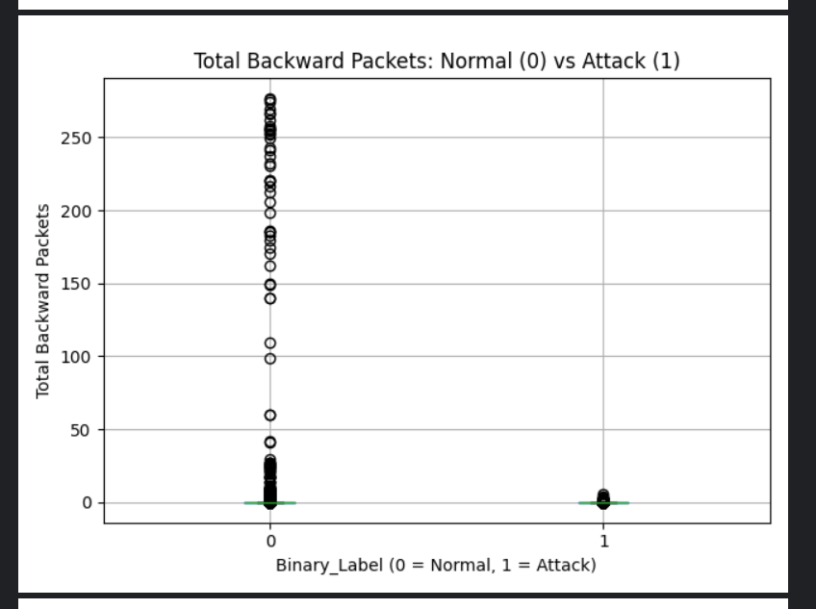
This shows that attackers get very few replies because the target server is already overwhelmed but the normal traffic have back-and-forth traffic.
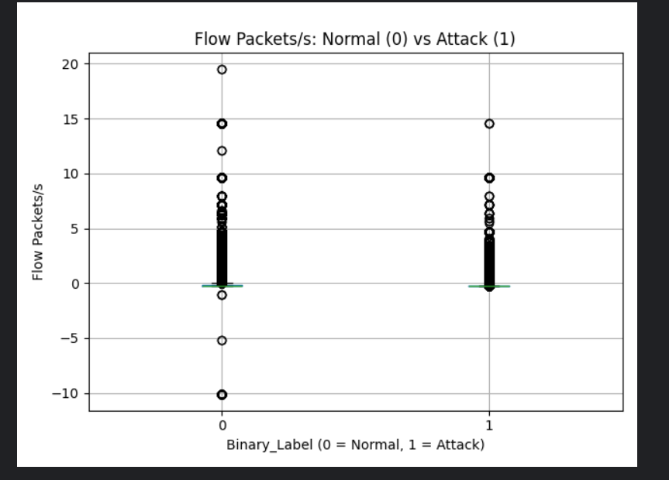
As you can see, both of them are almost same and hence out of 5, this is the weakest one for telling normal from attack.
OVERALL:
Flow duration = separates the classes the best
Total fwd/bwd packets: show partial difference
Flow bytes and flow packets: almost no visible difference but still may help when combined with other features.
We are plotting these graphs, because we are trying to considere these features in X to train the model and hence before we actually use them, we have to know whether these really help in traing the model.
- Comparing attack types against each other.
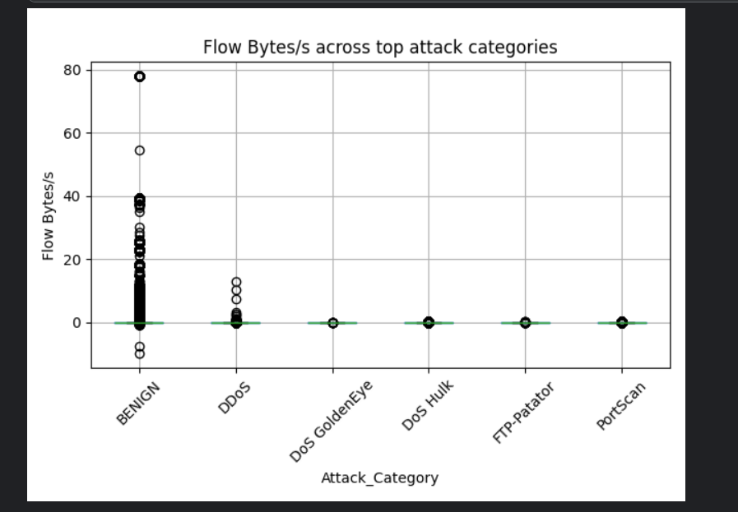
In this we are trying to compare the flow of bytes in a traffic for normal and specific categories rather han just taking noe attack category for all the attacks.
You can see that the normal traffic is messy, this is because real users do many different things.
You can notice that the same is not for the attacks. The flow of bytes is uniform. Each attack generates repetitive traffic such as repetitive password checking or probing the packets as in portscan attack.
The above feature is weak but can be combined with the other features to train the model.
- Correlation heatmap: finds columns that say the same thing twice. For example, "packets sent" and "packets received" rise and fall together (correlation about 1.0). That's redundant information.

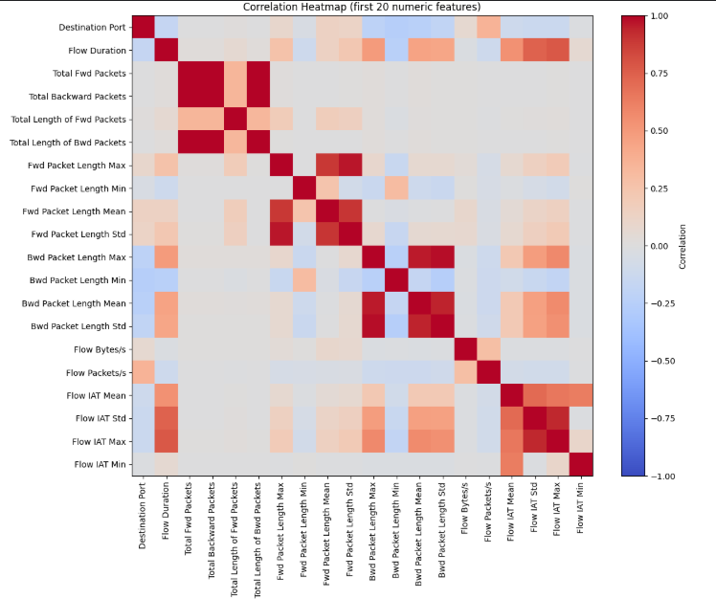

- As you can see, the one with dark red squares are highly corelated.
- If 2 features are corelated then we can remove one because they both give laost the same information and hence if both are used for training then the models like logistic regression may not perform well(multicollinearity). And hence we remove the redundant features like this.
- Suspiciously perfect features: checks whether one column alone could separate attack from normal perfectly, which would be a red flag for a data collection quirk. The ranges overlapped, so nothing was suspicious.

Part 3: Building the robot guard, yes or no
Three different "brains" (models) were trained to answer "normal or attack?" and compared:
Model | What it is (simple) | Result
Logistic Regression | Draws one straight dividing line between normal and attack. Simple baseline. | Decent, but misses about 14% of attacks
Random Forest | Hundreds of "decision trees" (chains of yes/no questions) voting together. | Very good, but slowest (about 7 minutes)
XGBoost | Trees that learn from each other's mistakes. | Best and fast (about 34 seconds)
The notebook doesn't just report "accuracy," because with 83% normal traffic, a lazy robot that always says "normal" would already score 83%. It uses more telling measures:
- Recall: of all real attacks, how many did we catch? XGBoost: 99.86%. It missed only 117 of about 85,000.
- Precision: when it shouts "attack!", how often is it right? XGBoost: 99.67%.
- False Positive Rate: how often does it wrongly accuse normal traffic (a false alarm)? XGBoost: 0.07%.
- Confusion matrix: a 2×2 scoreboard of right and wrong answers.
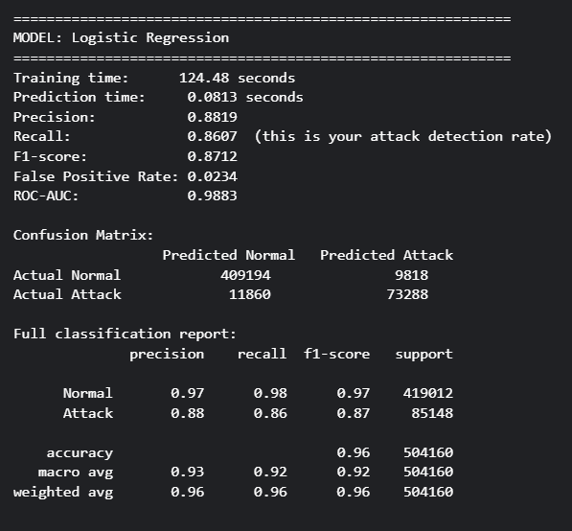

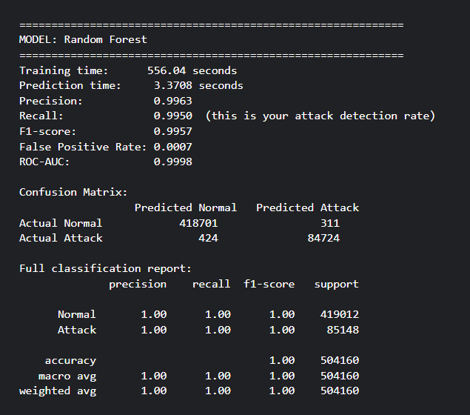

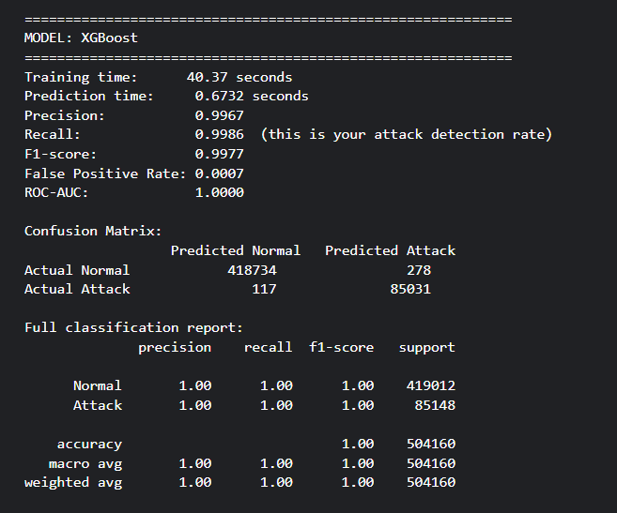
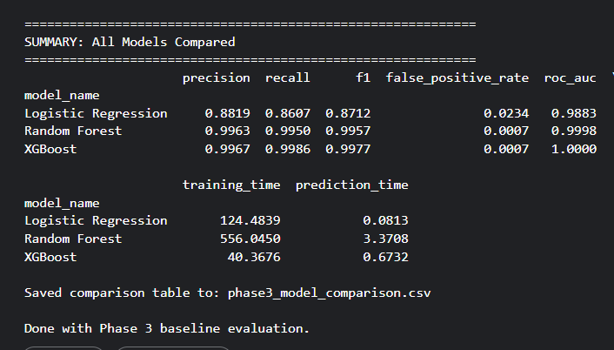
Winner: XGBoost, with about 99.8% F1 (a single score blending precision and recall).
Part 4: Which attack is it?
Now the robot has a harder job: not just "attack or not," but "which attack?"
- Attack types with fewer than 50 training examples (Infiltration, SQL Injection, Heartbleed) were removed, because there isn't enough data to learn from or fairly test on.
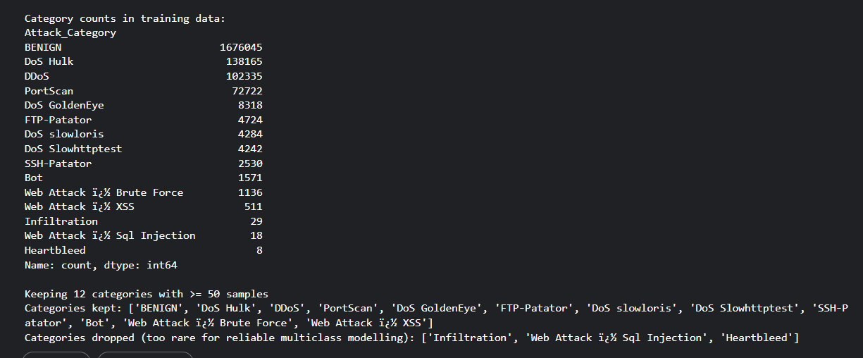
- Names were converted to numbers (models need numbers), and XGBoost was retrained for 12 categories.
Till here, Phase 4 is completed.

